**Module-5**

**GSM mobile phone**

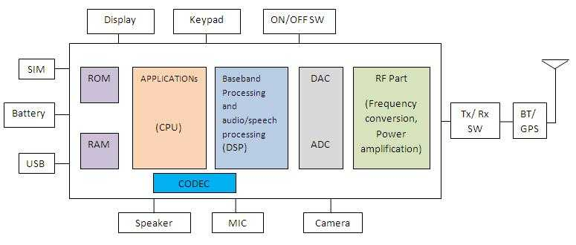

**Fig.1 GSM mobile phone block diagram**

**RF Part**  
RF part consists of RF frequency up converter and rf frequency down converter. Up converter converts modulated baseband signal either at zero IF(Intermediate frequency) or some IF to RF frequency(890-915 MHz). RF down converter converts RF signal (935 to 960 MHz) to baseband signal.

**Baseband Part**  
This part basically converts voice/data to be carried over GSM air interface to baseband signal. It is ported usually on DSP(Digital Signal Processor) to meet latency and power requirements of mobile phone. For Speech/audio, codec is used to compress and decompress the signal to match the data rate to the frame it has to fit in. CODEC converts speech at 8 KHz sampling rate to 13 kbps rate for full rate speech traffic channel.

**ADC and DAC**  
ADC(Analog to Digital Converter) and DAC(Digital to Analog Converter) is used to convert analog speech signal to digital signal and vice versa in the mobile handset. At Transmit path, ADC converted digital signal is given to speech coder. AGC(Automatic Gain Control) and AFC(Automatic Frequency Control) is used in the receiver path to control gain and frequency.

**Applicationlayer**  
It also runs on CPU. various applications run in GSM mobile phone. It include audio,video and image/graphics applications. It supports various audio formats such as MP3,MP4,WAV,rm. JPEG image formats are usually available.

**Operating system**  
various operating systems are supported in mobile phone such as Symbian,java,android,RT-Linux,Palm. It runs on CPU of different manufacturers. For time critical applications RTOS (real-time operating system) is used.

**Battery**  
It is the only major source of power to make/to keep mobile phone functional. There are various types of batteries made of Nickel Cadmium(NiCd),Nickel Metal Hydride(NiMH), based on lithium,Li-ion and so on. The major factors for designers is to reduce battery size, last for more talk time,increase battery life. Battery comes usually with 3.6 or 3.7 voltage and 600mAh or 960 mAh ratings. Battery Charger is usually provided with mobile phone to charge the mobile phone battery. Battery charger is AC to DC converter.

**Connectivity (WLAN, Bluetooth, USB, GPS)**  
To make data transfer fast enough between mobile phone and other computing devices(laptop,desktop,tablet) or between mobile and mobile various technologies are evolved which include WLAN,Bluetooth,USB. GPS(global positioning system) is used for location assistance and will enable google map to work efficiently.

**Microphone**  
Microphone or mic converts air pressure variations(result of our speech) to electrical signal to couple on the PCB for further processing.

**Speaker**  
It converts electrical signal to audible signal(pressure vibrations) for human being to hear. This is often coupled with audio amplifier to get required amplification of audio signal.

**Camera**  
It is the major specifications in increasing cost of mobile phone. There are various mega pixel camera for mobile phones are available such as 12 mega pixel, 14 mega pixel and even 41 mega pixel available in smartphones.This has become evident because of advancement in sensor technology.If one wants to buy low cost mobile phone, they usually go for non camera mobile phone.

**Display**  
There are various display devices used in mobile phone such as LCD(liquid crystal display), TFT(Thin-film transistor) screen,OLED(organic light emitting diode),TFD(thin film diode), touch screen of capacitive and resistive type etc.

**Keypad**  
Earlier days keypad was simple matrix type keypad which contains numeric digits( 0 to 9), alphabets( a to z),special characters and specific function keys. These has been designed for various applications such as accepting call,rejecting call,cursor movement(left,right,top,down) dialling number, typing name/sms/mms and so on.

**Generation of** [**Cellular & Wireless Technologies**](https://www.slideshare.net/kaushal_kaith/3g-4g-5g)

|  |  |  |  |  |  |
| --- | --- | --- | --- | --- | --- |
| Generation (1G,2G,3G,4G,5G) | Technology | Data Bandwidth | Standard | Time period | Features |
| 1G | Analog | 2 Kbps | AMPS,NMT,TACS | 1970 – 1980 | During 1G Wireless phones are used for ***voice only***. |
| 2G | Digital Narrow band circuit data | 14.4 Kbps | TDMA,CDMA | 1990 to 2000 | 2G capabilities are achieved by allowing ***multiple users on a single channel via multiplexing***. During 2G Cellular phones are used for ***data also along with voice***. |
| 2.5G | Packet Data | 16 Kbps | GPRS | 2001-2004 | In 2.5G the ***internet***becomes popular and data becomes more relevant.2.5G ***Multimedia services***and streaming starts to show growth. ***Phones start supporting web browsing*** though limited and very few phones have that. |
| 3G | Digital Broadband Packet Data | 2 Mbps | CDMA 2000  UMTS, EDGE | 2004-2005 | 3G has ***Multimedia services support*** along with streaming are more popular. In 3G, ***Universal access*** and ***portability*** across different device types are made possible. (Telephones, PDA’s, etc.) |
| 4G | Digital Broadband Packet All IP Very high throughput | 200 Mbps | WiMax LTE Wi-Fi | Now | ***Speeds***for 4G are further increased to keep up with data access demand used by various services. ***High definition streaming***is now supported in 4G. New phones with HD capabilities surface. It gets pretty cool. In 4G, ***Portability*** is increased further. ***World-wide roaming*** is not a distant dream. |
| 5G | Not Yet | Probably gigabits | Not Yet | Soon (probably 2020) | ***Currently there is no 5G technology deployed***. When this becomes available it will provide very high speeds to the consumers. It would also provide efficient use of available bandwidth as has been seen through development of each new technology. |

**GSM Network Architecture**

The GSM network architecture consists of four main parts:

* Mobile station (MS)
* Base-Station Subsystem (BSS)
* Network and Switching Subsystem (NSS)
* Operation and Support Subsystem (OSS)

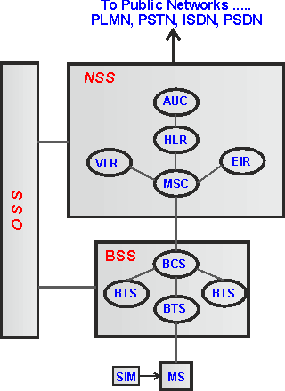  
**Fig: Simplified GSM Network Architecture Diagram**

**Mobile station**

Mobile station (MS)/mobile equipment (ME)/cell/mobile phone is the section of a GSM cellular network that the user sees and operates. There are number of elements in the cell phone. The two main elements are the main hardware and the SIM.

The hardware itself contains the main elements of the mobile phone including the display, case, battery, and the electronics used to generate the signal, and process the data receiver and to be transmitted. It also contains a number known as the International Mobile Equipment Identity (IMEI). This is installed in the phone at manufacture and "cannot" be changed. It is accessed by the network during registration to check whether the equipment has been reported as stolen.

The SIM or Subscriber Identity Module contains the information that provides the identity of the user to the network. It contains are variety of information including a number known as the International Mobile Subscriber Identity (IMSI).

**Base Station Subsystem (BSS)**

The Base Station Subsystem (BSS) section of the GSM network architecture that is fundamentally associated with communicating with the mobiles on the network. It consists of two elements:

* ***Base Transceiver Station (BTS):***   The BTS used in a GSM network comprises the radio transmitter receivers, and their associated antennas that transmit and receive to directly communicate with the mobiles. The BTS is the defining element for each cell. The BTS communicates with the mobiles and the interface between the two is known as the Um interface with its associated protocols.
* ***Base Station Controller (BSC):***   The BSC forms the next stage back into the GSM network. It controls a group of BTSs, and is often co-located with one of the BTSs in its group. It manages the radio resources and controls items such as handover within the group of BTSs, allocates channels and the like. It communicates with the BTSs over what is termed the Abis interface.

**Network Switching Subsystem (NSS)**

The GSM system architecture contains a variety of different elements, and is often termed the core network. It provides the main control and interfacing for the whole mobile network. The major elements within the core network include:

* ***Mobile Services Switching Centre (MSC):***   The main element within the core network area of the overall GSM network architecture is the Mobile switching Services Centre (MSC). The MSC acts like a normal switching node within a PSTN or ISDN, but also provides additional functionality to enable the requirements of a mobile user to be supported. These include registration, authentication, call location, inter-MSC handovers and call routing to a mobile subscriber. It also provides an interface to the PSTN so that calls can be routed from the mobile network to a phone connected to a landline. Interfaces to other MSCs are provided to enable calls to be made to mobiles on different networks.
* ***Home Location Register (HLR):***   This database contains all the administrative information about each subscriber along with their last known location. In this way, the GSM network is able to route calls to the relevant base station for the MS. When a user switches on their phone, the phone registers with the network and from this it is possible to determine which BTS it communicates with so that incoming calls can be routed appropriately. Even when the phone is not active (but switched on) it re-registers periodically to ensure that the network (HLR) is aware of its latest position. There is one HLR per network, although it may be distributed across various sub-centres to for operational reasons.
* ***Visitor Location Register (VLR):***   This contains selected information from the HLR that enables the selected services for the individual subscriber to be provided. The VLR can be implemented as a separate entity, but it is commonly realised as an integral part of the MSC, rather than a separate entity. In this way access is made faster and more convenient.
* ***Equipment Identity Register (EIR):***   The EIR is the entity that decides whether a given mobile equipment may be allowed onto the network. Each mobile equipment has a number known as the International Mobile Equipment Identity. This number, as mentioned above, is installed in the equipment and is checked by the network during registration. Dependent upon the information held in the EIR, the mobile may be allocated one of three states - allowed onto the network, barred access, or monitored in case its problems.
* ***Authentication Centre (AuC):***   The AuC is a protected database that contains the secret key also contained in the user's SIM card. It is used for authentication and for ciphering on the radio channel.
* ***Gateway Mobile Switching Centre (GMSC):***   The GMSC is the point to which a ME terminating call is initially routed, without any knowledge of the MS's location. The GMSC is thus in charge of obtaining the MSRN (Mobile Station Roaming Number) from the HLR based on the MSISDN (Mobile Station ISDN number, the "directory number" of a MS) and routing the call to the correct visited MSC. The "MSC" part of the term GMSC is misleading, since the gateway operation does not require any linking to an MSC.
* ***SMS Gateway (SMS-G):***   The SMS-G or SMS gateway is the term that is used to collectively describe the two Short Message Services Gateways defined in the GSM standards. The two gateways handle messages directed in different directions. The SMS-GMSC (Short Message Service Gateway Mobile Switching Centre) is for short messages being sent to an ME. The SMS-IWMSC (Short Message Service Inter-Working Mobile Switching Centre) is used for short messages originated with a mobile on that network. The SMS-GMSC role is similar to that of the GMSC, whereas the SMS-IWMSC provides a fixed access point to the Short Message Service Centre.

**Operation and Support Subsystem (OSS)**

The OSS or operation support subsystem is an element within the overall GSM network architecture that is connected to components of the NSS and the BSC. It is used to control and monitor the overall GSM network and it is also used to control the traffic load of the BSS. It must be noted that as the number of BS increases with the scaling of the subscriber population some of the maintenance tasks are transferred to the BTS, allowing savings in the cost of ownership of the system.

Anti-Lock Braking System

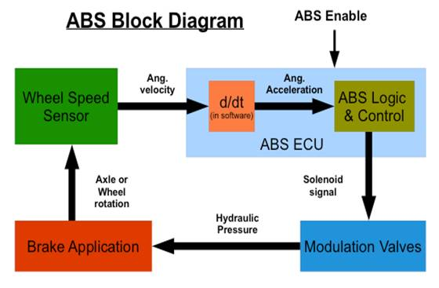

Antilock braking system (ABS) prevent brakes from locking during braking. In normal braking situation the driver control the brakes, however during severs braking or on slippery roadways when driver the wheels to approach lockup, the antilock takes over here. The ABS modulates the brake line pressure independent of the pedal force to bring the wheel speed back to the slip level range that necessary to the optimal braking performance. The ABS does not allow full wheel lock under braking. In simple terms, during emergency of braking, the wheel does not get locked even if you push a full auto brake pedal and hence the skidding does not takes place.

**Electronic Control Unit (ECU):**

1. A micro computer that functions as the ``brain'' of the ABS system.
2. The ECU receives wheel performance data from each wheel sensor.
3. When the wheels try to lock, the ECU delivers commands to the hydraulic valves to control brake pressure.

**Hydraulic control unit or modulation valve unit**

1. It receives operating signals from the ECU to apply or release the brakes under ABS conditions.

2. Hydraulic control unit controls the brake pressure in each wheel cylinder based on the inputs from the system sensor. This in result controls the wheel speed.

**Break application unit**

Whenever hard braking situation occur, the system sense the change in the rotation of the speed sensor and decide whether to hold or release pressure to a brake circuit.

**Wheel sensor unit**

1. It monitors the rotational speed of the wheel and transmits this data to the ABS control module.

2. If a wheel-speed sensor signals a lock up - the ECU sends a current to the hydraulic unit. This stops the braking pressure at that wheel from rising, and keeps it constant. It allows wheel velocity to increase and slip to decrease.

**Internet of Things or IoT**

**BUILDING BLOCKS of IoT**

Basic building blocks of IoT system include –sensors, processors, gateways, applications. Each of these nodes has to have their own characteristics in order to form a useful IoT system.

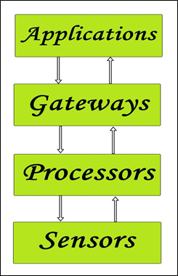

**Figure 1:** Simplified block diagram of the basic building blocks of the **IoT**

**Sensors:**

These form the front end of the IoT devices. These are the so called “Things” of the system. Their main purpose is to collect data from its surrounding (sensors) or give out data to its surrounding (actuators).

These have to be uniquely identifiable devices with a unique IP address so that they can be easily identifiable over a large network.

These have to be active in nature which means that they should be able to collect real time data. These can either work on their own (autonomous in nature) or can be made to work by the user depending on their needs (user controlled).

Examples of sensors are: gas sensor, water quality sensor, moisture sensor etc.

**Processors:**

Processors are the brain of the IoT system. Their main function is to process the data captured by the sensors and process them so as to extract the valuable data from the enormous amount of raw data collected. In a word, we can say that it gives intelligence to the data.

Processors mostly work on real-time basis and can be easily controlled by applications. These are also responsible for securing the data – that is performing encryption and decryption of data.

Embedded hardware devices, microcontroller etc are the ones that process the data because they have processors attached to it.

**Gateways:**

Gateways are responsible for routing the processed data and send it to proper locations for its (data) proper utilization.

In other words, we can say that gateway helps in to and fro communication of the data. It provides network connectivity to the data. Network connectivity is essential for any IoT system to communicate.

LAN, WAN, PAN etc are examples of network gateways.

**Applications:**

Applications form another end of an IoT system. Applications are essential for proper utilization of all the data collected.

Examples of applications are: home automation apps, security systems, industrial control hub etc.

**HOW IoT WORKS**  
  
  
First, it acquires information with respect to basic resources (names, addresses and so on) and related attributes of objects by means of automatic identification and perception technologies such as RFID, wireless sensor and satellite positioning, in other words the sensors, RFID tags and all other uniquely identifiable objects or "things" acquire real-time information (data) with the virtue of a central hub like smartphones.  
  
Second, by virtue of many kinds of communications technologies, it integrates object-related information into the information network and realizes the intelligent indexing and integration of the information related to masses of objects by resorting to fundamental resource services (similar to the resolution, addressing and discovery of the internet).  
  
Finally, utilizing intelligent computing technologies such as cloud computing, fuzzy recognition, data mining and semantic analysis, it analyzes and processes the information related to masses of objects so as to eventually realize intelligent decision and control in the physical world.

**IoT ARCHITECTURE**  
  
There are four major layers.

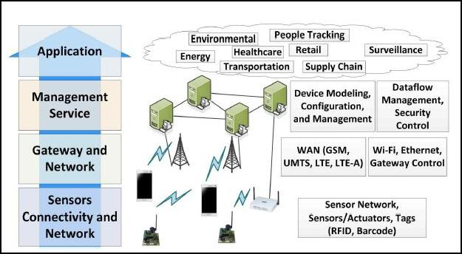

**Sensor, Connectivity and Network Layer**

* This layer consists of RFID tags, sensors (which are essential part of an IoT system and are responsible for collecting raw data). These form the essential “things” of an IoT system.
* Sensors, RFID tags are wireless devices and form the Wireless Sensor Networks (WSN).
* Sensors are active in nature which means that real-time information is to be collected and processed.
* This layer also has the network connectivity (like WAN, PAN etc.) which is responsible for communicating the raw data to the next layer which is the Gateway and Network Layer.

**Gateway and Network Layer**

* Gateways are responsible for routing the data coming from the **Sensor, Connectivity and Network layer** and pass it to the next layer which is the **Management Service Layer**.
* This layer requires having a large storage capacity for storing the enormous amount of data collected by the sensors, RFID tags etc. Also, this layer needs to have a consistently trusted performance in terms of public, private and hybrid networks.

**Management Service Layer**

* This layer is used for managing the IoT services. Management Service layer is responsible for Securing Analysis of IoT devices, Analysis of Information, Device Management.
* Data management is required to extract the necessary information from the enormous amount of raw data collected by the sensor devices to yield a valuable result of all the data collected. This action is performed in this layer.

**Application Layer**

Application layer forms the topmost layer of IoT architecture which are responsible for effective utilization of the data collected.

Various IoT applications include Home Automation, E-health, E-Government etc.

**Smart Home automation**

Smart Home automation refers to handling and controlling home appliances by using micro-controller or computer technology.

BLOCK DIAGRAM
 

The home automation using Internet of Things connects devices and control remotely through internet. The system not only monitors the sensor data, like temperature, gas, light, motion sensors, but also actuates a process according to the requirement, for example switching on the light when it gets dark. It also stores the sensor parameters in the cloud (Gmail) in a timely manner. This will help the user to analyze the condition of various parameters in the home anytime anywhere.

The model consists of number of relays to connect various devices. Initially all the devices are connected to the internet through Wi-Fi. When the connection is established in on web page we provide virtual switches to operate the connected devices. If particular device exceeds the threshold set point then server will give notification to the user on web page and that device will automatically turned off.

Passive Infrared Sensor (PIR) is an electronic device which is designed to detect this IR wavelength when a human being is in its proximity. PIR motion sensors are installed at the entrances of a building. This signal which detects the presence of human beings becomes the input trigger for the micro-controller.

Raspberry Pi: The main processing and controlling unit of the system. It has four USB ports, allowing the connection of different peripherals to it such as keyboard, mouse, memory stick or Wi-Fi dongle, that allows its connection to wireless internet.

The home automation system has the capability to monitor and control the following:

Temperature and humidity

Motion detection

Fire and smoke detection

Light/Fan on/off

**ADVANTAGES**

(a) Adds Safety Through Appliance and Lighting Control

(b) Secures Home Through web control Increases Convenience through Temperature Adjustment

(c) Save time

(d) Save money and increase convenience

(e) Allow to appliances control when out of towndraulic pres

**Telemetry**

**Telemetry** is an automated communications process by which measurements and other data are collected at remote or inaccessible points and transmitted to receiving equipment for monitoring. The function of Telemetry sub system is to monitor various aircraft parameters and to transmit the measured values to the satellite control centre.

Telemetry involves three steps: a. converting measured quantity to signal b. Transmission of that signal over proper channel c. Its reconversion to actual data for recording, displaying(CRT) for graphical analysis and further computation

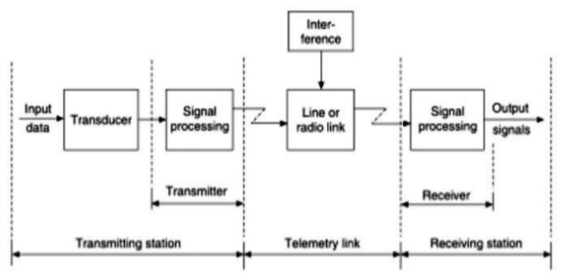

1. It refers to the overall operation of generating an electrical signal proportional to the quantity being measured and encoding and transmitting this to a distant station, which for the satellite is one of the earth stations.
2. The telemetry data are analyzed at the control centre is used for routine operation and failure diagnostic purposes.
3. The parameters most commonly monitored are:

1) Voltage, current and Temperatures of all major systems

2) Switch status of communications transponders.

3) Pressure of propulsion tanks

4) Output from attitude sensors

5) Reaction wheel speed

6) Environmental information such as the magnetic field intensity and direction, the frequency of meteorite impact.

1. Several sensors provide analog signals whereas some others provide digital signals.
2. Analog signals are digitally encoded and multiplexed with other signals, forming a continuous digital stream. Typical telemetry data rates are in the range of 150 to 100 bps.
3. The telemetry data are transmitted as FSK, PSK via telemetry antenna. The telemetry signal is commonly used as a beacon by ground stations for tracking purpose

**DEMERITS AND MERITS**

Merits:

* Effective for short distance measurement
* V and I can be easily transmitted
* Circuitry required is simple
* Wide variety of primary sensing elements are available to measure reqd. variable.

Demerits:

* Demands high S/N ratio that is difficult to calibrate.
* Need to be protected from EMI, noises and distortions in the channel.
* Multiplexing is difficult
* Limited frequency response